**IMPACT TEST**

**INTRODUCTION:-**

In manufacturing locomotive wheels, coins, connecting rods, etc the components are subjected to impact (shock) loads. These loads are applied suddenly. The stresses induced in these components are many more times than the stresses produced by gradual loading. Therefore, impact tests are performed to assess the shock absorbing capacity of materials subjected to suddenly applied loads. Impact strengths are generally lower compared to strengths achieved under slowly applied loads.

**OBJECTIVE:-**

To determine the impact strength of the steel specimen by Izod and Charpy test.

**APPARATUS: -**

Impact testing machine, steel specimens of 75mm X 10mm $X$ 10mm.

**THEORY:-**

Of all types of impact tests, the notch bar tests are most extensively used. Therefore, an impact test measures the energy necessary to fracture a standard notch bar by applying an impulse load. The absorbed energy is a measure of given material’s toughness and acts as a tool to study temperature-dependant brittle-ductile transition due to lowering of temperature.

There are two types of notch impact tests:-

1. Charpy test
2. Izod test

The charpy piece is supported horizontally between two anvils and the pendulum strikes opposite the notch. The izod piece is supported as a vertical cantilever beam and is struck on the free end projecting over the holding vice.

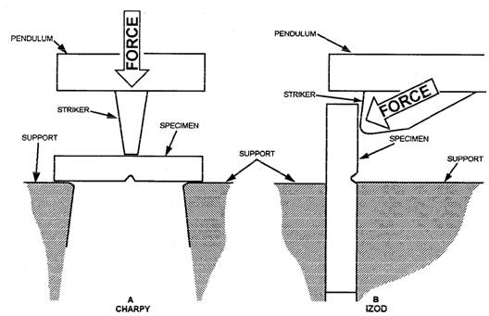

**PROCEDURE:-**

1. Lift the hammer to an appropriate knife edge position and note the energy stored in the hammer.

2. Firmly hold the steel specimen in impact testing machine’s vice depending on the type of the notch impact test.

3. Release the hammer. The hammer will break the piece and shoot up the other side of the specimen.

4. Note the residual energy indicated on the scale by the hammer.

5. Impact strength of the test specimen is the difference of the initial energy stored in the hammer and the residual energy.

|  |  |  |  |  |
| --- | --- | --- | --- | --- |
| **TEST TYPE** | **SL NO** | **INITIAL ENERGY(e1) (J)** | **RESIDUAL ENERGY(e2)**  **(J)** | **ABSORBED ENERGY(e1-e2)**  **(J)** |
|  |  |  |  |  |
|  |  |  |  |  |
|  |  |  |  |  |
|  |  |  |  |  |

**OBESERVATION:-**

**CALCULATION:-**

Notch impact strength = Absorbed energy/effective cross sectional area

**PRECAUTIONS:-**

1. Measure the dimensions of the specimen carefully.

2. Hold the specimen in the respective manner depending on the type of impact test, firmly.

3. Note down readings carefully.

4. Do not stand in front of the swinging hammer.

5. Make the loose pointer in contact with the fixed pointer after setting the pendulum.

6. Take readings more frequently.

**RESULT:-**

**Izod test:**

Impact strength of material =

**Charpy test:**

Impact strength of material =

**REFERENCE:-**

http://en.wikipedia.org/wiki/Charpy_impact_test

http://en.wikipedia.org/wiki/Izod_impact_strength_test

http://www.tcreng.com/services/impact-test-charpy-izod.shtml

Mechanical Experiments and Workshop Practice Textbook

By G S Sawhney

**QUIZ:-**

1. Name two types of impact tests? What are their differences?

2. Which material has higher impact strength? Mild steel or stainless steel? What is its significance?

3. What is the necessity in making a notch in the specimen before testing?

4. Does the size of the notch have any effect on the impact strength of the material?

